STUDENT RECORD MANAGEMENT SYSTEM

PROJECT REPORT

s

**MEMBERS:**

MISBAH REHMAN (CT-23018)

DANIA NOOR (CT-23010)

ISHA MURTAZA (CT-23019)

SAMEER (CT-23047)

mmis

**Problem Statement:**  
Without Student record system, institutes will have to tolerate many problems regarding the information of each student therefore , It is noted that keeping track of students’ data manually is arduous and not a professional way to organize data of every student.

**Proposed Solution:**

Like any information system, its aim is to solve problems by storing data, extracting information, and using it to improve knowledge. In pragmatic terms, this means that a well-designed Student Record Management System will Store and safeguard student information.

**List of functionalities:**

Student record system manages the report of students via:

* Adding in new records
* Deleting existing records
* Modifying existing records
* Searching existing records
* Viewing the list of students containing their information

**Screenshot of each functionalty:**

Adding a record:

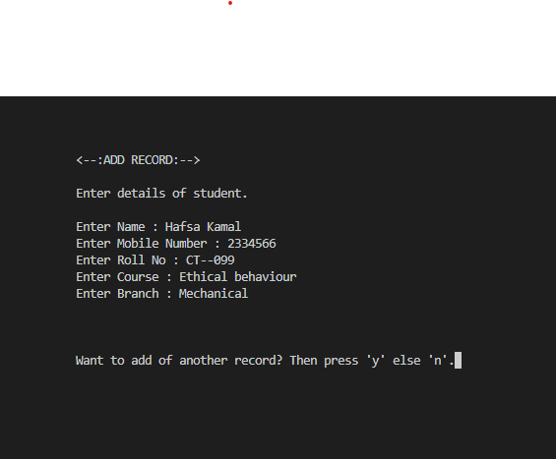

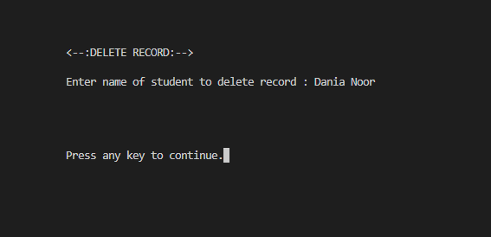Deleting a record:

Modifying a record:

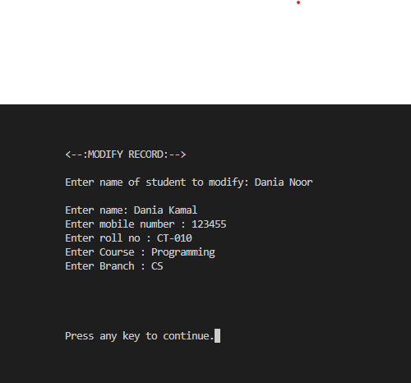

Searching a record:

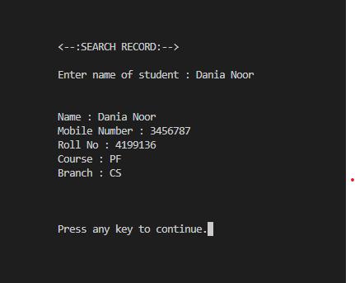

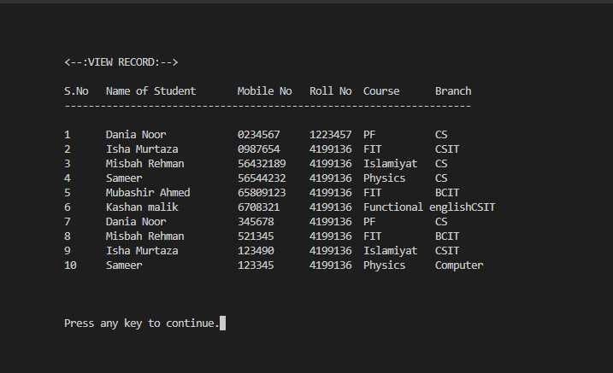Viewing the list of record:

**TECHNOLOGY AND TOOLS:**

MAIN TECHNOLOGY:

* **VSCode**

*C-Programming Technology We Will Use:*

To develop this simple student management system project we will use the common functionality of the c-programming language like:

1. For loop

2. While loop 3. If-else

4. Structure

5. Function

6. Array

Some Built-In Functions We Will Use

1. system("cls"): The system("cls") function is used to clear the window.
2. strlen(): The strlen() function is used to calculate the string length.
3. strcpy(): The strcpy() function is used to copy one string to another.
4. strcmp(): The strcmp() function is used to compare two strings, is they are the same or not?